**EC2, VPC, IAM task**

# Description

This module is an intro to Amazon Web Services(AWS). We will learn how to work with basic services such as EC2, IAM, VPC in the scope of this module. We will create a root AWS account and set up several users by Identity and Access Management (IAM), create and run Web server(EC2) and Postgres DB (RDS) servers and set up Virtual Private Cloud(VPC) with subnets for these servers.

**Diagram**

# 

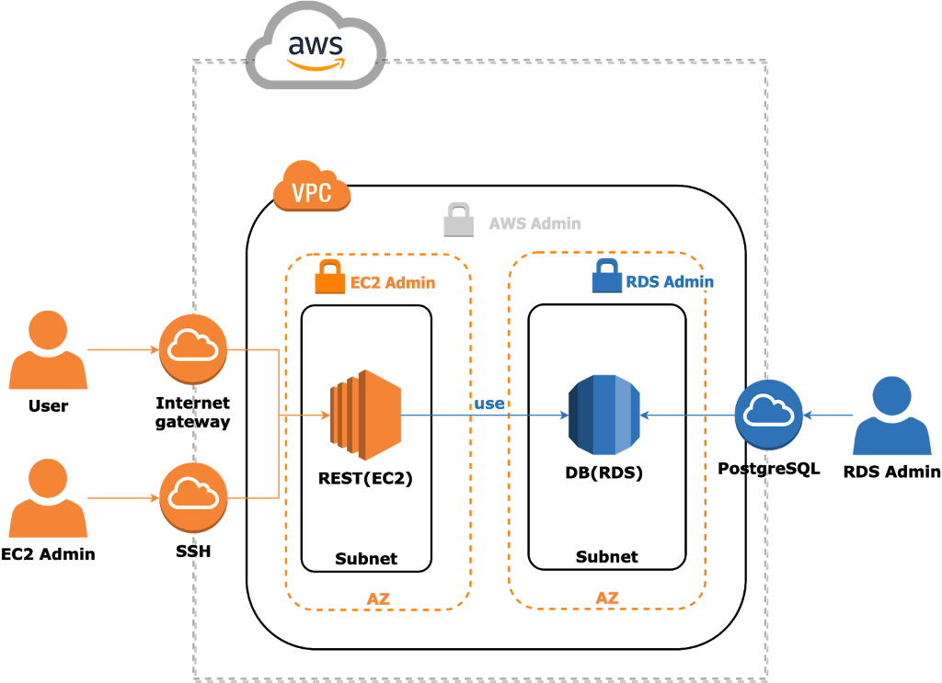

User:

* A user uses REST for management products accessible via Internet Gateway.
* REST Web Server hosted on EC2 instance processes these requests and saves them into Postgres DB(RDS).

EC2 Admin:

An EC2 Admin manages EC2 via SSH connection type:

* Start/Stop the instance
* Deploy/Run/Stop the REST Web Application

RDS Admin:

A RDS Admin manages EC2 via PostgreSQL connection type:

* Start/Stop the instance
* Update DB Schema for application needs
* Maintenance PostgreSQL server

AWS Admin:

* Manage IAM roles
* EC2 Admin
* RDS Admin
* Manage Security groups
* Allows IPs for SSH connection type to EC2 for EC2 Admin
* Allows IPs for PostgreSQL connection type to RDS for RDS Admin

# Homework

Also, please [read](https://aws.amazon.com/ru/free/) information about free tiers of AWS

At the end of this homework you need to have:

AWS Admin (your user that can manage everything in account)

EC2 Admin user that can connect to your EC2 users via SSH and can`t work with RDS

RDS Admin user that can manage RDS, but can`t manage EC2

VPC with 2 subnets and security groups (will provide security group configuration as basic EPAM configuration)

2 EC2 instances

EC2 instance with your application from Spring homework  
 EC2 instance with RDS

RDS should have configured update and backup policy

E-mail notification should be sent to RDS admin and AWS admin on configuration changes

* Create AWS account. Create IAM users:
* EC2 Admin.
* RDS Admin.

    1 point

* Create VPC with 2 subnets and set up separate security groups for these subnets and restrict connection types from internet to this VPC:
* REST
* DB

    1 point

* Create servers from AMI for:
* Web Application(EC2). Install OpenJDK 1.8
* DB(RDS). PostgreSQL DB.

    1 point

* Setup RDS
* Configure update and backup policy.
* Send email notification to Administrator and DB Admin on Event(exchange configuration)

    1 point

* Deploy application from your Spring to EC2 server and migrate DB to RDS.   
  Note: you should create EC2 instance and run your application on it

    1 point

**Extra mile:**

Migrate your DB to DynamoDB and use it in your application – 2 points

Total mark is 7. 5 points for regular homework and 2 points for extra mile.